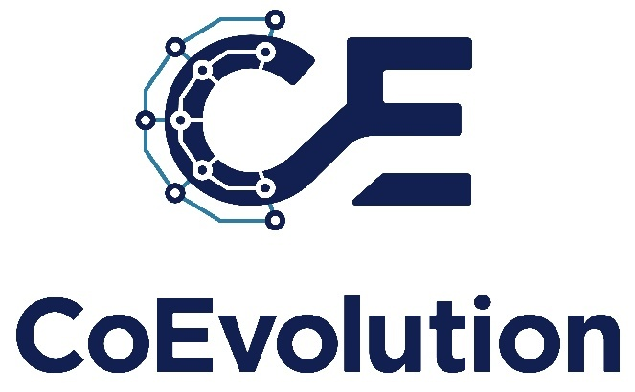
A Comprehensive Trustworthy Framework for Connected Machine Learning and Secure Interconnected AI Solutions.

D1.2 Data Management Plan

Editor: | Name Surname
Beneficiary: | XXX
Version: | 0.1
Status: | Draft
Delivery date: | dd/mm/20yy
Dissemination level: | PU (Public) / SEN (Sensitive)

Deliverable Information
Deliverable Revisions
Consortium
Disclaimer for Deliverables
Table of Contents
Executive Summary 4
1 Introduction 5
1.1 Purpose of the document 5
1.2 Contribution to other deliverables 5
1.3 Definitions 5
2 Data Summary 6
2.1 Overview of datasets 6
2.2 Dataset descriptions 6
2.2.1 Dataset A 6
2.2.2 Dataset B 7
2.3 Administrative data 7
2.4 Dissemination & Communication 7
2.5 Exploitation 7
2.6 Standardisation 7
3 FAIR Data 8
3.1 Making data findable, including provisions for metadata 8
3.1.1 Discoverability of the data 8
3.1.2 Data identification mechanisms 8
3.1.3 Naming conventions used. 8
3.1.4 Clear versioning of the documents 8
3.1.5 Standards for metadata creation 8
3.2 Making data openly accessible 8
3.2.1 Methods or software needed to access the data. 8
3.2.2 Deposit of data, associated metadata, documentation and code 9
3.3 Making data interoperable 9
3.3.1 Interoperability of data assessment 9
3.3.2 Vocabulary use 9
3.4 Making data re-usable 9
3.4.1 Increase data re-use through clarifying licenses. 9
3.4.2 Data quality assurance process 9
3.4.3 Length of time for which the data will remain re-usable. 9
3.4.4 Data description templates in CoEvolution 10
4 Allocation of Resources 11
4.1 Data management responsibilities 11
4.2 Cost of potential value of long-term preservation 11
5 Data Security 12
5.1 Data storage and access 12
5.2 Data security measures 12
5.3 Data backup and recovery 12
5.4 Data transfer 12
5.5 Data breach response and notifications 12
6 Ethics and Legal Aspects 13
6.1 Compliance with GDPR and other legislation and regulations 13
6.2 Additional Considerations 13
6.3 Use of A.I. 13
7 Conclusions 14
8 References 15
9 APPENDIX A CoEvolution DMP Questionnaire v1.0 16

Executive Summary
This is the summary of this deliverable document. It should state the main findings of this part of the work.
[This section will provide an overview of the document's organization.]

Introduction

Purpose of the document
[This section will outline the aims of the DMP and its scope within the CoEvolution project, emphasizing its alignment with project objectives.]

Contribution to other deliverables
[This section will explain how the DMP supports or interlinks with other deliverables and work packages.]

Definitions
[In this section several key terms and concepts related to data management will be defined in the form of a Table]

Data Summary

Overview of datasets
[This section will summarize the types and nature of data used in CoEvolution.]
No | Name of Dataset | Responsible Partner | Description of Accessibility
01 | Dataset A | Partner X | Open Access/ Restricted Access / Other (Please specify)
02 | Dataset B | Partner Y
03 | Dataset C
…

Dataset descriptions
[This section will provide detailed information about each dataset's characteristics.]

Dataset A
Name of Dataset
Accessibility:
Purpose and relation to the objectives of the project
Data types
Data Formats
Reuse of existing data
Data origin
Expected size of the data
Data utility
Privacy principles

Dataset B
…

Administrative data
[This section will discuss data related to project management]

Dissemination & Communication
[This section will discuss data related to D&C]

Exploitation
[This section will discuss data related to Exploitation]

Standardisation
[This section will discuss data related to Standardisation]

FAIR Data
[Presentation of the “FAIR” four fundamentals principles]

Making data findable, including provisions for metadata
[This section will detail strategies for ensuring data discoverability. For example, it might discuss the use of metadata standards.]

Discoverability of the data
[This section will discuss how data can be easily located and identified. For instance, “Data sets will be indexed in major scientific databases to enhance discoverability”.]

Data identification mechanisms
[This section will describe systems for uniquely identifying data. For example, “Each dataset will be assigned a DOI (Digital Object Identifier) for easy tracking.”]

Naming conventions used.
[This section will explain the naming system for files and datasets. An example: “Datasets will follow a standardized naming convention, including project acronym, data type, and date.”]

Clear versioning of the documents
[This section will include detail version control methods for documents. For instance: “Document versions will be clearly marked with version numbers and modification dates”.]

Standards for metadata creation
[Standards and guidelines for metadata will be specified in this section for example: “Metadata will adhere to the Dublin Core standard, ensuring comprehensive description and easy retrieval”]

Making data openly accessible
[This section will describe how data will be accessed, including necessary methods or software. For example, it may outline a secure repository with controlled access for data storage: “Data will be accessible via a dedicated web portal with user authentication”.]

Methods or software needed to access the data.
[In this section we will list specific tools or software required for data access if any is mentioned from partners in the DMP Q. For instance: “Access to certain datasets will require specialized software, which will be listed alongside the dataset”.]

Deposit of data, associated metadata, documentation and code
[In this section we will explain the process for depositing data and related materials. For example: “Datasets, along with their metadata and documentation, will be deposited in the project online repository”.]

Making data interoperable
[In this section we will discuss strategies to ensure data can be integrated with different systems. An example could be, “Data formats will be selected for their compatibility with common industry standards”.]

Interoperability of data assessment
[This section will describe how data compatibility is evaluated. For example: “We will conduct regular reviews to ensure ongoing interoperability of our datasets with emerging standards”.]

Vocabulary use
[This section will explain the use of standard vocabularies for data exchange to ensure consistent understanding across different systems and stakeholders. For example: “We will employ the SKOS vocabulary for standardized categorization of cybersecurity terms.”]

Making data re-usable
[This section will focus on strategies to enhance the reuse of data. An example: “Data in CoEvolution will be structured to facilitate easy reuse in future cybersecurity research.”]

Increase data re-use through clarifying licenses.
[This section will detail licensing agreements for data reuse. For instance: “All datasets will be released under the Creative Commons Attribution 4.0 International License.”]

Data quality assurance process
[This section will outline procedures for ensuring data integrity and quality. An example could be the following: “Regular audits and peer reviews will be conducted to maintain high data quality.”]

Length of time for which the data will remain re-usable.
[This section will specify the duration of data usability. For example: “Datasets will be maintained in a reusable format for a minimum of 5 years.”]

Data description templates in CoEvolution
[This section will provide templates or examples for data description. For example: “Each dataset will include a template detailing its source, format, and potential applications.”]

Allocation of Resources

Data management responsibilities
[This section will assign roles and responsibilities for data management. For example: “The Technical Coordinator will be responsible for overseeing technical dataset curation and archiving”.]

Cost of potential value of long-term preservation
[This section will evaluate the cost and potential value of long-term data preservation.]

Data Security

Data storage and access
[This section will outline the strategy of the project for handling data storage and access (e.g. Sharepoint for central data storage, GitHub/GitLab for technical work, Zenodo for publications, etc.]

Data security measures
[This section will address data security measures and protocols.]

Data backup and recovery
[This section will present the established backup plan and the recovery procedure]

Data transfer
[This section will describe the procedure for transferring data between project partners]

Data breach response and notifications
[This section will describe the incident response plan for potential data breaches]

Ethics and Legal Aspects

Compliance with GDPR and other legislation and regulations
[This section will discuss adherence to legal standards, especially GDPR. For example: All data processing activities will comply with the General Data Protection Regulation (GDPR).”]

Additional Considerations
[This section will highlight the additional data protection regulations that have to be considered for specific sectors (e.g. critical infrastructures, healthcare, etc.]

Use of A.I.
[This section will briefly outline the ethical considerations and applications of AI in data management. It will also suggest mitigation strategies concerning AI.]

Conclusions
[This section will summarize the main points and projected outcomes of the DMP.]

References

APPENDIX A CoEvolution DMP Questionnaire v1.0

